

PR I **Z M**

WHITE PAPER

Revision March 2017

THIS DOCUMENT DESCRIBES THE **PRIZM** INITIAL CONCEPT



**INTRODUCTION**

Bitcoin is the world's first decentralized digital currency, allowing you to easily store and transfer cryp­ tographic coins using the P2P network to transmit information, hashing as a synchronization signal to pre­ vent double spending, as well as a powerful scripting system to determine the owner of coins. This has a growing technology and business infrastructure. According to the original design, bitcoins are inter­ changeable, acting as a neutral means of exchange. Bitcoins may have special properties supported by either the Issuer or a public agreement, and have a value independent of the nominal value underlying it. Bitcoin has proven that the P2P electronic payment system can really work and process payments without the involvement of a third party.

However, for the entire e-economy to be based on a fully decentralized peer-to-peer solution, the system must be able to do the following:

1. **Process transactions securely, quickly and efficiently, in the amount of thousands per hour or more;**
2. **Encourage people to participate in network security;**
3. **Scale at the global level with the minimum consumption of resources;**
4. **And to be able to work on a wide range of devices including mobile.**

PZM (pronounced as " Pr izm 1 satisfies all these conditions. And also has the additional advantage,

' )

unique advantage, called, Pyramiding, which is not in any of the existing cryptocurrencies. But more on that later.

##### REVIEW



**3**

_I_

**4**

**5**

**2**

I

**1**

Blocks are generated every 60 seconds, on average, by accounts that are not blocked on network nodes. PZM are redistributed by incorporating transaction fees that are awarded to an account when it success­ fully creates a block. This process is known as forging and is akin to the notion of "mining" used by other cryptocurrencies. Transactions are considered secure after 10 block confirmations, and the current archi­ tecture and block size of the PZM allow processing up to 367,200 transactions per day.

PZM includes the implementation of Transparent Forging that will allow you to increase the performance of transaction processing by two orders of magnitude by using the generation algorithm is deterministic block, in combination with additional security mechanisms of the network.

**Z M**

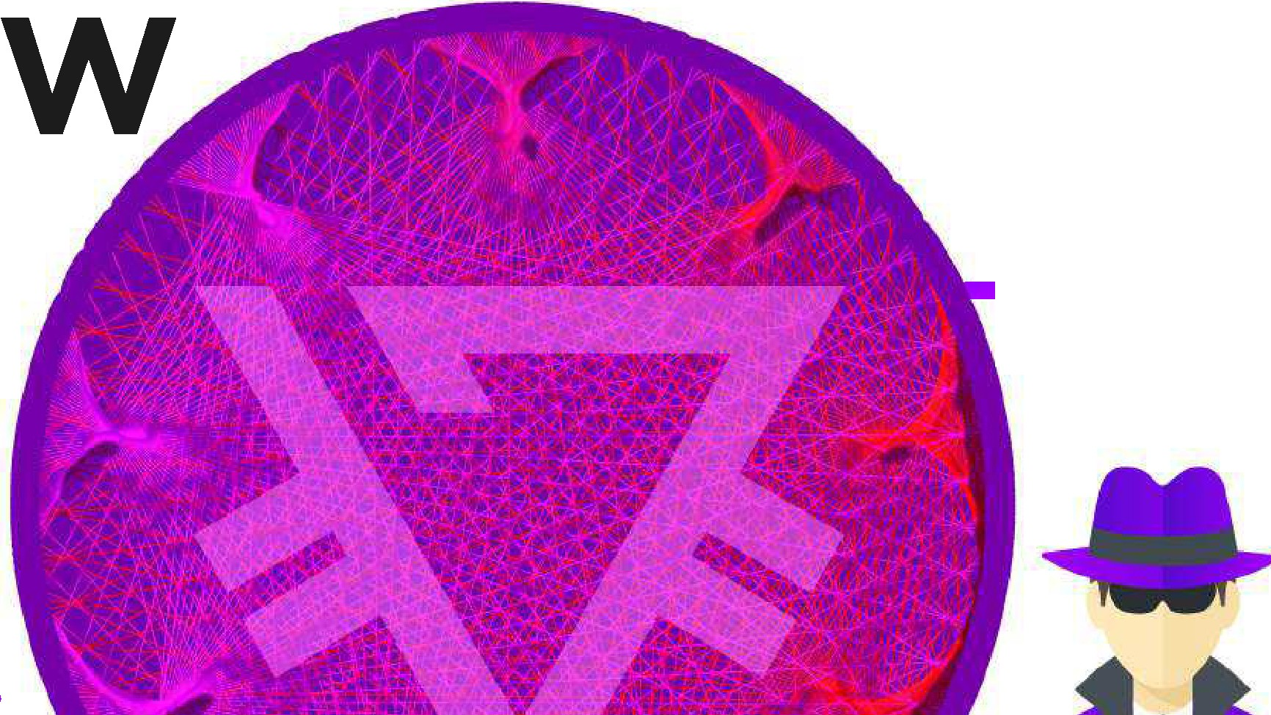

**IE**

PR

I

I I

I I

I I

I **PRIZM** I



BLOCKCHAIN

**REVIEW**

**PRIZM** - it is a 100% proof-of-steak cryptocurrency based on the NEXT-kernel, built on Java with an open

source co de. The unique PRIZM proof-of-steak algorithm does not depend on any implemen t at io n of the

,rcoin age" concept used by other proof-of-steak cryptocurrencies, and is resistant to the so-called irnoth­ ing at stake" att acks . The total number of coins available was d ist ribut ed in the Genesis block. Curve25519 cryptography is used to provide a balance of security and the required processing power along with the more commonly used SHA256 hashing algo rit hm s.

**TE IES**

**PR I Z M**

In the traditional **"Proof of Work"** modelused by the majority of cryptocurrencies, network security is ensured by participants performing "work". They use their resources (calculation/pro­ cessing time) to reconcile transactions with double costs and impose extraordinary costs on those who attempt to collapse transactions. For this work, participants are awarded with PZM, and their frequency and amount vary depending on the working parameters of the cryptocurrency. This process is known as mining. The frequency of block generation, which determines each available reward for mining cryptocurrencies, as a rule, should remain constant.

As a result, the labor intensity of the work required to obtain re­ wards should increase as the network becomes more efficient.

As the Proof of Work network develops, the individual user has less incentive to support the network, as their potential reward is distributed among more colleagues. In search of profitability miners continue to invest resources in the form of specialized, patented equipment that requires significant investment and high current energy costs. Over time, the network becomes more centralized as smaller partners (those who can do less work) drop out or pool their resources into pools. The Creator of bitcoin Satoshi Nakamoto, intended to bitcoin network was completely decentralized. But no one could predict that the incentives provided by Proof of Work systems would lead to the centralization of the mining process. This leads to potential vulnerabilities.

GHash. The bitcoin 10 pool has reached 51% of bitcoin mining power in the past, and the top five bitcoin mining pools make up 70% of the hashing power of the network. The concept of decentralization is at risk of total loss.

**PRO O F OF STAKE MODEL**

In the **Proof of Stake model** used by Prizm, network security is regulated by partners who have a stake in the net­ work.The incentives provided by this algorithm are not conducive to centralization as Proof of Work algorithms.and data shows that the Prizm network remains highly decentralized since its inception: a large (and growing) number of unique accounts contributing blocks to the network, and five top accounts generate 35% of the total number of blocks.

**PR I Z M**

**PRO OF OF STAKE MODEL IN PRIZM**

Prizm uses a system in which each "coin" in the account can be considered as a minia­ ture mining rig. The more coins you have in your account, the more likely it is that your account will be entitled to create a block. The total "reward" received as a result of the block creation is the sum of transaction commissions located inside the block. PZM does not create any new coins as a result of building blocks.

PZM redistribution occurs as a result of block generators receiving transaction fees, so the term "forging" (used in this context to "create relationships or new conditions" instead of "mining"). Subsequent blocks are generated based on verifiable, unique, and almost unpredictable information from the previous block.

Blocks are linked by virtue of these links, creating a chain of blocks (and transactions) that can be traced back to the Genesis block. Block generation time is approximately 59 seconds, but changes in the probabilities have led to the fact that the average gen­ eration time of the block can be 80 seconds, there are longer intervals of blocks. The security of the Blockchain is always set in the system Proof-of-steak.

**PRO O F OF STAKE**

**THE BASIC PRINCIPLES APPLY TO**

**THE PRIZM PROOF OF STAKE ALGORITHM:**

The cumulative complexity value is stored as a parameter in each block, and each subsequent block receives its new "complexity" from the value of the previous block. In the case of ambiguity, the network achieves con­ sensus by choosing a block or chain fragment with the highest cumulative complexity.

In order for account holders not to move their funds from one account to another as a means of manipulating in order to be able to generate blocks, coins must be stationary within the account for 1,440 blocks before they can contribute to the block generation process. Coins that meet this criterion contribute to an efficient account balance, and that balance is used to determine the probability of forging.

To prevent an attacker from creating a new chain all the way from the Genesis block, the network allows only the restructuring of the chain of 720 blocks located behind the current block. Any block below this threshold shall be rejected. This move threshold can be considered as THE only fixed PZM checkpoint.

Due to the extremely low probability that any account will take over the Blockchain management by creating its own chain of blocks, transactions are considered safe if they are encoded into a block that is 10 blocks lo­ cated behind the current block.

**COMPARSION WITH PEERCOIN PRO O F O F STAKE**

Peercoin uses the setting of the age of the coin as part of the algorithm the probabili­ ty of mining. In this system, the longer your Peercoins have been on your account (up to 90 days), the more power (coin age) they have to create a block. The act of "Meet­ ing" the block requires the consumption of the dignity of the coin age, and the net­ work determines the consensus by selecting the chain with the greatest total con­ sumed coin age. When the Peercoin blocks are separated, the consumed coin age is returned back to the original block account.

As a result, the cost to attack the Peercoin network is low, since the intruders can con­ tinue to try to generate blocks (called grinding the steak) until then, until they are successful. Peercoin minimizes these and other risks by centrally publishing block­ chain checkpoints several times a day to "freeze" the blockchain and block transac­ tions.

Prizm does not use the coin age as part of the forcing algorithm. The" chance" of cre­ ating a block by any account depends only on its current balance (which is the advan­ tage of each account), the time since the last block (which is shared by all forging ac­ counts) and the base target value (which is also common for all accounts

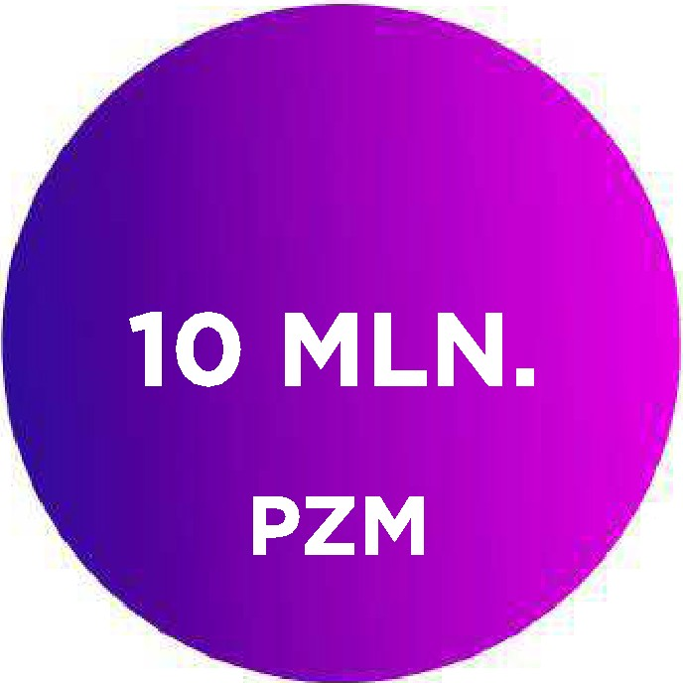**TOKENS**

The initial em ission is 10 m illion PZM and the final amount is 6 b illion PZM. The coins were issued with the creation of the Genesis block (the first block in the blockchain). Prem ining implemented in all countries of the world, at nominal cost, in limited quantities, to achieve the starting of decentralization Prizm. The total amount of PZM will be 6 billion tokens. Account Genesis generates ant i -coin sig ­ nals of Premining (signal to send the coins for a certain wallet) to the limit of minus 6 billion PZM

**The existence of anti-coins in Genesis has several interesting side effects:**

* All tokens sent to the Genesis account are effectively destroyed, as the negative account balance cancels them
* The main function of Prizm is the trad it ional payment system, but was created to do much more.

The goals *of* th e CWT community can be achieved under the condition of PZM p ar ity with the main Fiat currencies.

**( www.cw t.t op )**

**IN ITI AL EM I SSli ON**

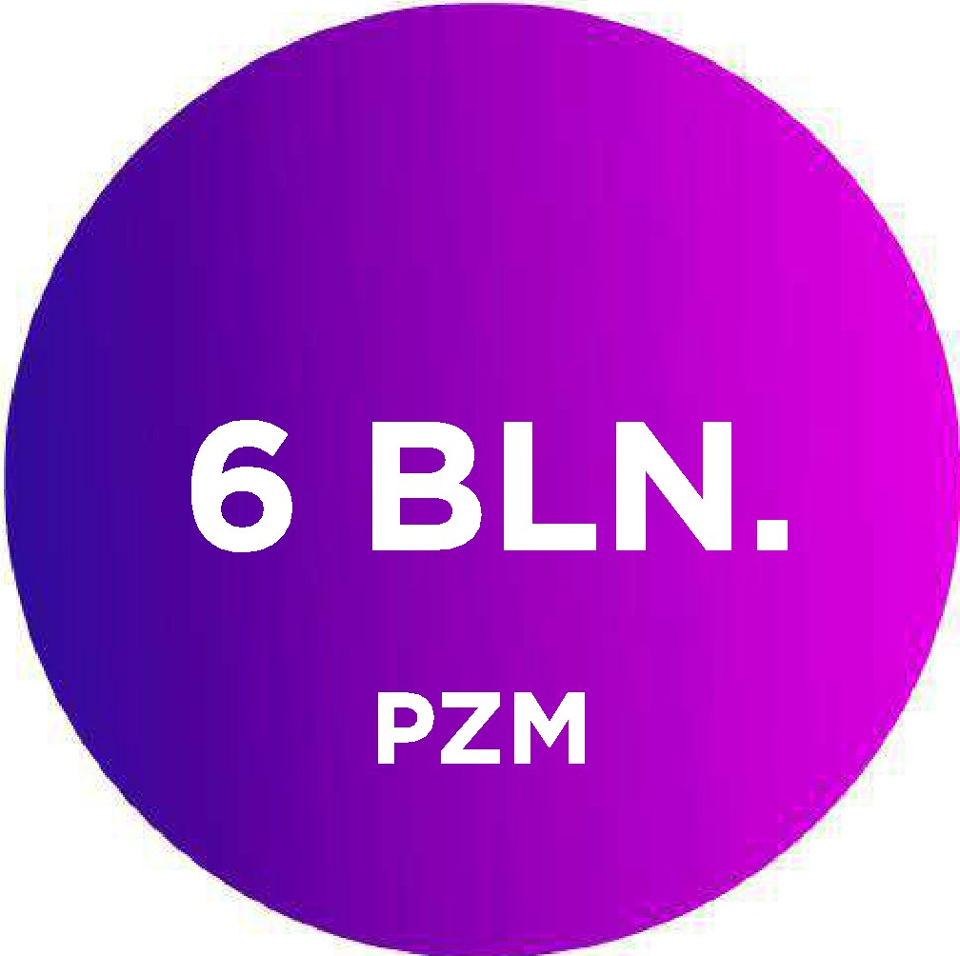

**FINAL AMOUNT**

# NETWORK NODE

A Prizm host is any device that makes a transaction or block data into the network. Any device with the PZM software is treated as a node. Nodes can be divided into two types: marked and regular.

A marked node is simply a node that is marked with an encrypted token received from the account's private key; this token can be decoded to show the specific PZM account address and balance that are associated with the node. The label placement act on a node adds a layer of accountability and trust, so that marked nodes are more reliable than those that do not have markings on the network. The more the balance of account is linked to a marked node, the more confidence is given to this node. While an attacker might want to mark a node to gain trust on the network and then use that trust for malicious purposes, the barrier to entry (the cost of PZM needed to build adequate trust) prevents such abuse.

Each node in the PZM network has the ability to process and transmit both transac­ tions and block information. Blocks are scanned as they are received from other nodes, and in cases where a block check is not performed, the nodes can be "black­ listed" temporarily to prevent the dissemination of invalid block data.

Each node has built-in DDOS protection mechanisms (Distributed Denial of services) that limit the number of network requests from any user to 30 per second.

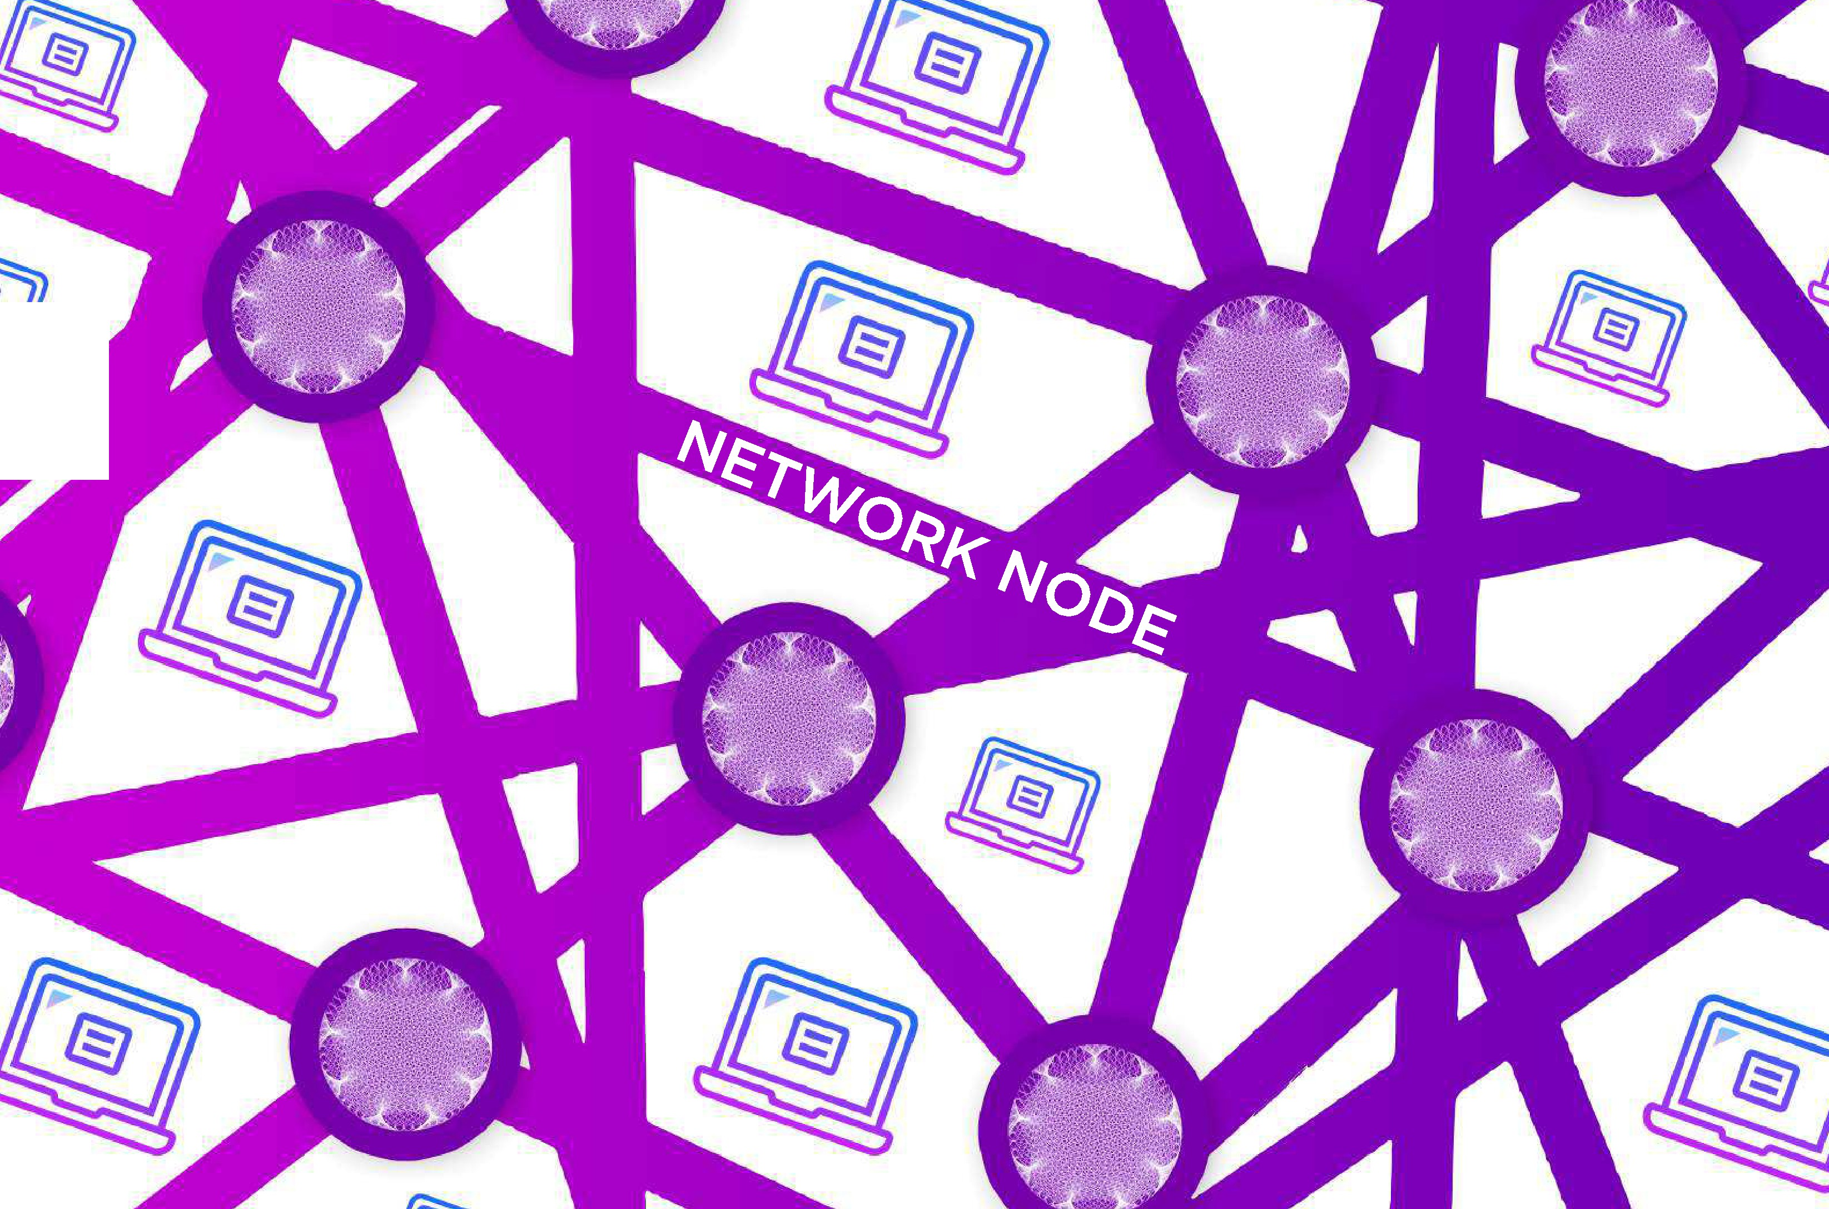

# BLOCKS

As with other cryptocurrencies, the PZM Ledger (Ledger of transactions) is built and stored in a linked series of blocks known as the blockchain. This workbook provides a permanent record of the transactions that have oc­ curred, and it also establishes the order in which the transactions were made. A copy of the Blockchain is stored on each node in the Prizm network, and each account that is not blocked on the node (by providing the private key of this account) has the ability to generate blocks, provided that at least one incoming transaction in the ac­ count has been confirmed 1,440 times.

Any account that meets these criteria is called an active account. In PZM, each block contains up to 255 transac­ tions, all of which are preceded by a 192-byte Header that contains identifying parameters. Each transaction in a block is represented by a maximum of 160 bytes, and the maximum block size is 32 KB.

All blo cks contain the following parameters:

* The version of the block, the height of the block and the bl oc k ID
* Block timestamp expressed in seconds from the Genesis block
* The ID of the account that created the block, as w ell as the public key of the account.
* ID and hash of the previous blo ck
* Number of transactions stored in the block
* The total amount of PZM rep resent ed by t ransac t io n s and commissions in the block
* Tran sac tion data for all t ransact ion s in clud ed in the block, including their transaction IDs
* Length of the pay load block and a value of a hash f unc t ion of the pay lo ad block
* The base target value and cumulative diffi cult y for the b l o ck

# BLOCKS

BLOCKCHAIN





#### CREATION OF BLOCKS

The three values are the key to determine which account has the right to generate a block, which account is entitled to create unit and what the unit is considered to be authoritative in times of conflict: under ly in g target value, targ et value and cumulative difficulty.

**FORGING**

**WHERE BE IS:**

the new target value

**The reference target value**

To win the right to forge (generate) block, all active Prizm ac­ counts "compete" by trying to create a hash value that is lower than the specified base target value. This base ta rg et value changes from block to block and is derived from the base target value of the previous block multiplied by the amount of time it took to generate that b lock .

**Target value**

Each account calculat es its own target value based on the current effective rate.

This value is equal:

**T** - **Tb x S x Be**

the reference target value

the elapsed time since the last block in seconds

**Tb**

the effective account balance

As you can see from the formula, the target value increases with every second that has passed since the previous block.

The maximum target value is 1,53722867 x 1017, and the minimum target value is half the base target value of the previous block. This target value and the base target value are the same for all accounts that are trying to to forge on top of a particular block. The only defined account parameter is an effective balance parameter.

**THE TOTAL COMPLEXITY**

The total value of complexity obtained from the reference target value according to the formula:

**Deb** --

###### WHERE BE IS:

**Dpb + 264/Tb**

**Dpb**

thecomplexity

of the current block

the complexity of the previous block

the base target value of the current block

#### FORGING ALGORITHM

Each block in the chain has a signature generation parameter. To participate in the forging process of a block, the active account cryptologically signs the previous generated block with its own public key. This creates a 64-byte signature that is then hashed using SHA256. The first 8 bytes of the resulting hash gives a number called the hit your account. The hit is com­ pared to the current target value. If the calculated hit is lower than the target, the next block can be generated.

As noted in the target value formula, the target value increases with each second. Even if there are only a few active accounts on the network, one of them will eventually generate a block because the target value will become very large. The consequence of this is that you can estimate the time it will take for any account to force the block by comparing the hit value of that account to the target value.

The last point is of great importance. Since any node can request an effective balance for any active account, it is possible to go through all active accounts to determine their individual hit value. This means that with reasonable accuracy, you can predict what the following account wins right to block counterfeit.

FORGING ALGORITHM





#### FORGING ALGORITHM

A shuffle attack can be triggered by moving a stake into an account that will generate the next block, which is another reason why PZM bet must be stationary for 1,440 blocks before it can con­ tribute to the forging (through an effective balance value).

Interestingly, the new base target for the next block cannot be reasonably predicted, so a virtually deterministic process of determining who will force the next block becomes more and more sto­ chastic as attempts are made to predict future blocks. This feature of the forging PZM algorithm helps to form the basis for the development and implementation of the Transparent Forging algo­ rithm. When an active account is granted the right to create a block, it combines up to 255 available unconfirmed transactions into a new block and populates the block with all its necessary parame­ ters. This block is then transmitted to the network as a Blockchain candidate. The payload that gen erates the account and all signatures on each block can be checked by all the network nodes that receive it.

In a situation where multiple blocks are generated, nodes will select the block with the highest ac­ cumulated complexity as the authoritative block. Because the block data is distributed among the members (peers), forks (unauthorized chain fragments) are detected and dismantled by examining the cumulative complexity of the chains stored in each fork.

## PARAMINING

Paramining is PRIZM's key advantage over other cryptocurrencies. PRIZM developers added a unique, linear-retrograde mechanism for determining the reward for funds storage aimed at economic attractiveness and gradual replacement of all existing financial instruments of the world by the mass of PZM to the basic mechanism of forming.

That is, in addition to the basic forging mechanism, which does not increase the amount of funds in the system. In PZM there is an additional mechanism ParaMining, which creates new coins, according to metrics of standard mathematics development of normalized financial system in the slice of the world economy. According to our calculations, only such a format of coin weight growth can provide a gradual and confident replacement of all existing economic instruments.

The speed of mining new coins with ParaMining is calculated from two main parameters, the number of coins on the personal wallet and the number of coins on the wallets of followers up to 888 levels. According to its characteristics, ParaMining is a system MLM 2.0 excludes from itself all that pushes a simple person from the network business, but at the same time involves him in the development of the network to increase the speed of coin mining on a personal wallet.

When making any transaction in the wallet, the ParaMining system records a blockchain con­ taining the value of the number of coins of the wallet owner and the number of coins in the wallets of his followers, at this moment new coins are generated for the balance of the wallet.

PARAMINING



### Your wallet

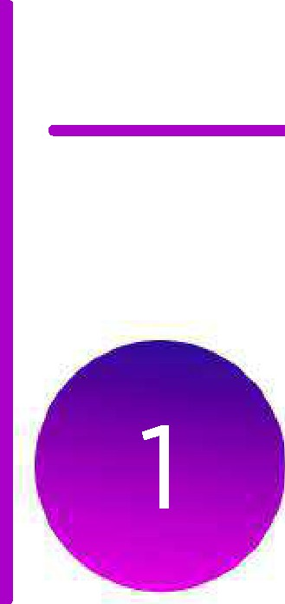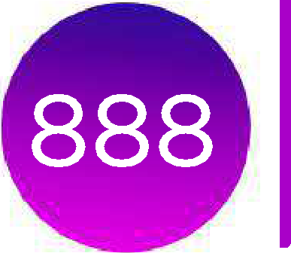

**1000 000 PZM**

**Structure**

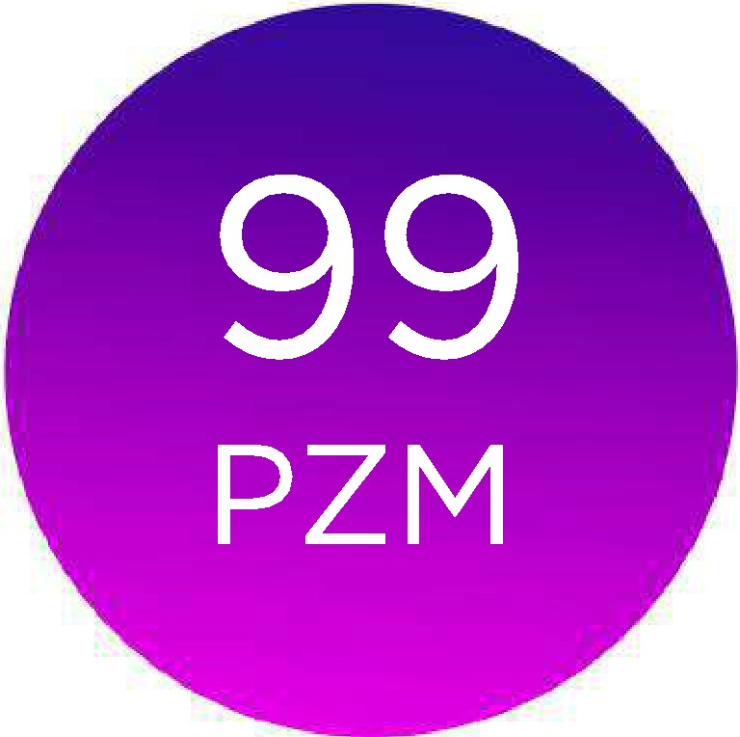

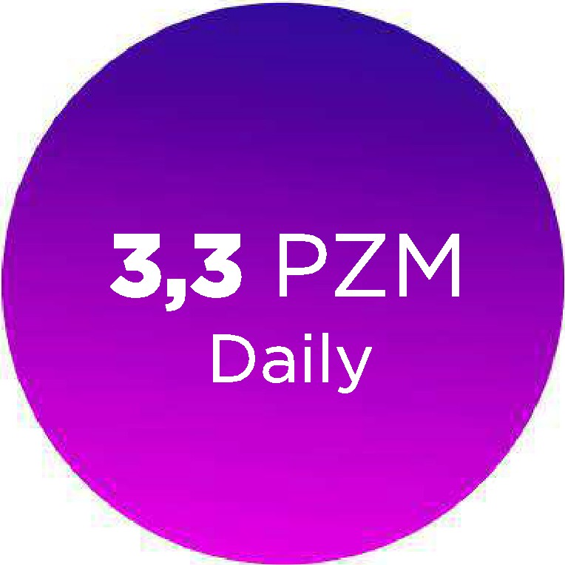**FOR EXAMPLE:**

With a purse 99PZM and lOOOOOPZM 888 levels of the structure apply the per­ centage growth of the number of coins of 0.12% and a multiplier of 2.77 which allows to generate 3.3 new coins daily, for depositing these coins to the balance enough to make any transaction. Thus, we get a system with a complex percent­ age, which to increase capitalization encourages the user to make transactions by connecting new holders of wallets, thereby increasing the turnover of its structure. According to conservative estimates, the average monthly number of

:oins that user is at least 10%

### PARAMINING

The ParaMining system is the most perfect tool for promotion and popularization, as it has no ana­ logues in any modern cryptocurrency. The main advantage of ParaMining is that no user of the net­ work can interfere with this mechanism and falsify new coins, all users can track the number of coins issued by the system in real time. ParaMining works on any wallet with a balance over 1 PSM and automatically stops when the balance reaches 1 min. PZM

Al so for t he first time t he system of estab lishi ng referral links wit hout usfng ,:my links. After creating a new wallet , the s.yst em fixes the first transact ion to the b loc kchain from whom it comes and forever est ablishes a referral chain that can not be chang ed, this makes it easy to build a g lo ba l MLM network and increase t he speed of ext ract ion of new coins ,

*The technical implementation is not described in detail at the moment because for all of us,* free *people, the main thing* - *is not to create 700 "dead11 tools, and one* - *with good support and good working. If our know-how is d isclo sed, then someone will definitely try it again and this will invol­ untarily lead to the dispersion of attention and the use of this idea not for noble and important for our planet purposes, but for purposes not known to us and not always characterized by a pos­ itive coloring intentions.*



To start mining a new PZM, just needed a single coin electronic wallet that automatically starts ParaMining. This is a process that allows you to increase the number of coins in the wallet without any costs of electricity.

Paramining starts with 1 coin and stops automatically when you reach 1 million coins in your wallet.

## PARAMANING OPTIONS

The number of coins in a personal wallet

1 parameter

Paramining is a unique method of creating new coins by all users simultaneously, regulated by two parameters:

**The number of coins in a personal wallet**

**the number of**

**The growth rate of**

**coins per day**

**from 500.000 to 1.000.000**

**0,18%**

**0,14%**

**0,12%**

**0,33%**

**0,28%**

**0,25%**

**0,21%**

**100.000 to 499.999**

**50.000 to 99.999**

**10.000 to 49.999 1000 to 9999 100 to 999**

**1 to 99**

According to preliminary calculations, the completion of ParaMining can occur after about **10-15 years,** since the generation of the first block.

The Paramining principle is based on the fundamental laws of physics, from the section "Visible radiation". Like the model of our Universe, the system is con­ stantly expanding, gaining speed.

#### The number of coins in the wallets of the followers

**of 888 levels deep** 2 parameter

The number of coins in the wallets of the followers

**Multiplier**



|  |  |
| --- | --- |
| **1.000.000.000** | **4,37** |
| **100.000.000 to 999.999.999** | **3,88** |
| **10.000.000 to 99.999.999** | **3,36** |
| **1.000.000 to 9.999.999** | **3,05** |
| **100.000 to 999.999** | **2,77** |
| **10.000 to 99.999** | **2,36** |
| **from 1000 to 9999** | **2,18** |

## PRIZM ACCOUNTS

Prizm implements a smart wallet as part of its design: all accounts are stored on the network with per­ sonal keys for each possible account address, direct ly derived from the code phrase of each account using a combination of operations SHA256 and Curve25519. Each account is represented by a 64-bit number, and this number is expressed as the account address using the error Correction of Solo­ mon-Code, which allows you to detect up to four errors in the address of the account or correct up to two errors. This format was implemented in response to concerns that an incorrect account address could result in coinsj aliases, or assets being irreversibly transferred to erroneous target accoun ts. Ac­ count addresses are always preceded by r, PRIZM -", which makes Prizm account addresses easily recognizable and distinct from the address formats used by other cryptocurrencies.

**Address account, coded Solomon-Code associated with a secret passphrase is generated in the following way:**

* 1. The secret passphrase is hashed using SHA256 to retrieve the account's private key.
  2. The private key is encrypted using Curve25519 to obtain the public li<ey of the ac count .
  3. The public key is hashed with SHA256 to obtain the account ID.
  4. The first 64 bits of the account ID are the visible account number.
  5. Encoding Solomon-Code, the visible account number with the prefix "PRIZM -" ge11erates the address of the accou nt.

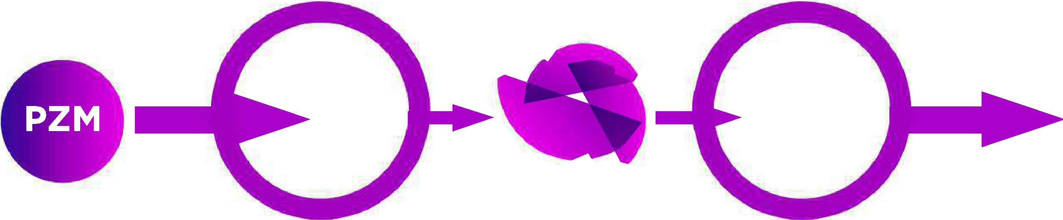

When an account is accessed with a secret passphrase for the first time, it is not protected by a public key. When the first outgoing transaction is made from the account, the 256-bit public key received from the passphrase is stored in the blockchain, and this protects the account. The address space for public keys (2256) is larger than the address space for account numbers (264), so there is no one-to-one matching of code words to account numbers and possible collisions. These collisions are detected and prevented as follows: after a certain passphrase is used to access the account, and the account is protected with a 256-bit public key, no other public-private key pair can access this account number.

**The properties of the account's balance:**

For each Prizm account is available at several different levels of balance. Each type serves a different pur­ pose, and many of these values are validated as part of the validation and transaction processing.

1. An effective account balance is used as the basis for billing your account. An effective account balance consists of all the coins that were stationary on that account for 1,440 blocks. In addition, the" account Leasing "function allows you to set an effective balance on another account for a temporary period.
2. The guaranteed account balance consists of all tokens that were stationary on the account for 1440 units. Unlike an efficient balance sheet, this balance cannot be assigned to any other account.
3. The base account balance accounts for all transactions that have at least one confirmation.
4. The boost account balance shows the total amount of PZM received as a result of the successful forcing blocks.
5. Unconfirmed account balance is the one that is displayed in Prizm clients. It represents the current account balance, net of the coins involved in uncon­ firmed, sent transactions.
6. Guaranteed asset balances list (make a list) guaranteed balances of all assets associated with a particular account.
7. Unconfirmed balances and unconfirmed asset balance list of all assets associated with a specific account.



**WALLET.DAT**

Bitcoin and related currencies often use an encrypted file, under the name and wallet, to store generated addresses for receiving coins. The Next core used in the Prizm does not simulate this functionality, but doesn't rule it out. Client developers can implement a system in which a private key group for Prizm ac­ counts is stored in an encrypted stand-alone file.

**Confirmation of transactions**

All PZM transactions are considered unconfirmed until they are included in a valid network block. The newly created blocks are distributed to the network by the node (and the associated account) that creates them, and the transaction that is included in the block is considered to be one confirmation received. Because subsequent blocks are added to an existing blockchain, each additional block adds another confirmation to the number of transaction confirmations. If a transaction is not included in the block before it expires, it burns and is deleted from the transaction pool.

**The timing of the transaction**

Each transaction contains a deadline parameter set to the number of minutes since the transaction was sent to the network. By default, the deadline is 1440 minutes (24 hours). A transaction that was sent to the network but was not included in the block is called an unconfirmed transaction.

If the transaction was not included in the block before the transaction deadline, the transaction is removed from the network. Transactions can be left unconfirmed because they are invalid or distorted, or because blocks are filled with transactions that offer to pay a higher Commission. In the future, features such as multi-signature transactions can use deadlines as a means of enforcing expiration.

**Creating and processing of transactions**

Detailed information about creating and processing of a PZM transaction is as follows: The sender specifies the transaction parameters.

Transaction types change, and you specify the desired type when you create the transaction, but you must specify multiple parameters for all transactions:

* The private key for the sending account
* The transaction deadline
* Optional transaction reference



**BASICS OF**



**CRYPTOGRAPHY**

The key exchange in Prizm is based on the Curve25519 algorithm, which generates a shared secret using Diffie-Hellman's fast efficient elliptic curve with a high degree of protection. The algorithm was first demonstrated by Daniel J. Bernstein in 2006.

Next Java implementations were reviewed by Doctor Evil in March 2014. The signing of messages in Prizm is carried out using the ellip­ tic-Curve digital signature algorithm (EC-KCDSA), which was defined by the IEEE P1363a group in 1998 by the KCDSA Task force team. Both algorithms were chosen to balance speed and security for a key size of only 32 bytes.

#### MAIN FEATURES

**Advanced JavaScript client**

Convenient client application of the Second generation embedded in the distribution of the basic software Prizm, and which can be accessed via a local web browser. The client provides full support for all major Prizm features implemented so that users' private keys are never available online. It also includes an enhanced administrative interface and built-in Java­ doc documentation for the Prizm low-priority application programming interface.

**Basic payments**

The most fundamental feature of any cryptocurrency is the ability to transfer coins from one account to another. This is the most fundamental type of Prizm transactions, and it allows you to use basic payment functions.

**Portable device**

Thanks to its cross platform based on Java roots, the hashing of Proof of Stake and its future ability to reduce block chain size, Prizm is extremely well suited for use on small low-power low-resource devices. Android and iPhone apps and soft­ ware have been ported to low-power ARM devices such as the RaspberryPi and CubieTruck platforms. The ability to imple­ ment Prizm on low-power, always-connected devices such as smartphones allows us to present a scenario in which most Prizm networks are supported on mobile devices. Low cost and resource consumption of these devices significantly reduce network costs compared to traditional cryptocurrency Proof of Work.

**p IZ**

**KEY FEATURES**

1. POS - forging typing
2. Mixing the two technologies paramining + forging at the same time ParaMining. Source codes are closed (not lined), up to a certain time, as protection against clones as the guarantee that the system will be liquid.
3. Affiliate program - 888 levels in the structure
4. NEXT/ Proof of stake core of the cryptosystem
5. User-friendly interface for mobile devices
6. The user password is not being sent to the server

#### PROBLEMS

**NOTHING AT STAKE**

In the "nothing is at stake" attack, forgers try to build blocks on top of all the forks they see because it costs them almost nothing, and because ignoring any fork can mean losing on the block the rewards that would be earned if that fork were de­ signed to become the chain with the most cumulative difficulty. Although this attack is theoretically possible, it is currently impractical. Prizm network does not experience long blockchain forks, and the reward for low blocks does not give a strong incentive for profit; In addition, compromising network security and trust for such a small profit could make any victory a Pyrrhic.

**ATTACKS ON HISTORY**

In "attack on history," someone acquires a large number of coins, sells them, and then tries to create a successful fork just before their coins have been sold or exchanged. If the attack fails, the attempt is worthless because the coins are already sold or transferred; If the attack succeeds, the attacker gets his tokens back. Extreme forms of this attack include obtaining private keys from old accounts and using them to build a successful chain directly from the Genesis block. In Prizms, the main history attack usually fails because all bets must be fixed at 1,440 blocks before they can be used for forging; In addi­ tion, the effective account balance that each block generates is verified as part of the block check. The extreme form of this attack usually fails because the PRIZM blockchain cannot be reorganized by more than 720 blocks behind the current block height. This limits the time frame in which a bad actor could establish this form of attack.

PR I Z M



The Bitcoin problems, considered in Prizm.

Prizm was created as a cryptocurrency 2.0 - response to Bit­ coin. Prizm uses functions that are well established in Bitcoin, and consider the aspects of concern. This application address­ es issues with the Bitcoin Protocol and network that are smoothed out by Prizm technology.



About of transactions per day

By the end of 2013, the number of transactions processed in the Bitcoin network reached a maximum of 70,000 per day, which is about 0.8 transactions per second (tps). The current standard Bitcoin block size of one megabyte, generated (on average) every ten minutes on the "full" site of customers, limits the maximum bandwidth of the existing Bitcoin network to about 7 TPS. Compare this with the bandwidth of the VISA network to handle 10,000 TPS, and you'll see that Bitcoin can't compete as it exists today.

Blockchain Size

The Bitcoin Blockchain is a complete sequential collection of the generated data blocks containing the e-book registers all Bitcoin transactions that have taken place since its launch in January 2009th. Four years later, in January 2013th, Bitcoin's blockchain size was 4 gigabytes (GB) - the approximate amount of data needed to store a two-hour movie on a DVD. Eighteen months later, in July 2014th, the Bitcoin blockchain size increased by almost five-to 19 gigabytes (GB) 37. Bitcoin blockchain is undergo­ ing exponential growth, and modifications to the original Bitcoin Protocol will require a solution to this.

##### Answer of PRIZM

In its current state, Prizm can handle up to 367,200 trans­ actions per day - more than nine times the current Bitcoin peak. The Transparent Forging implementation allows transactions to be processed almost instantly, significantly increasing this limit.

Time to confirm transaction

**PR I Z M**

Transaction confirmation times for Bitcoin ranged from 5 to 10 min­ utes for the most part during 2013. After the announcement at the end of 2013th that Chinese banks would not be allowed to process Bitcoins, the average Bitcoin transaction time increased signifi­ cantly, to 8-13 minutes, with periodic peaks of 19 minutes. Since then, the confirmation time has shifted from 8 to 10 minutes. How­ ever, since several checks (usually six preferred confirmations) are required to complete a Bitcoin transaction, one hour can easily pass before the sale of assets paid for by Bitcoin is completed.

###### Answer of PRIZM

The average block generation time for PZM has historically been shown to be approximately 80 seconds, and the average transaction processing time was the same. Transactions are considered safe after ten confirmations, which means that transactions become permanent in less than 14 minutes. The implementation of Transparent

Forging which will further reduce this time.

allows you to make almost instant transactions,

Problems of centralization

The complexity increase and combined hash rate for Bitcoin has created a high barrier to entry for newcomers, and lower profits for existing mining installations. The incentive to encourage blocks used by Bitcoin has led to the creation of large single-tier installations of specialized mining equipment 44, as well as reli­ ance on a small set of large mining pools 45. This led to the effect of" centralization", where Large volumes of mining are concentrated in the control of a decreasing number of people. Not only does this create the kind of power structure that Bit­ coin has designed to bypass, but it also presents the real possi­ bility that a single mining operation or pool can gain 51% of the total mining capacity in the 46 network and perform a 51% attack. There are also attacks that require only 25% of the total network hashing power. In early January 2014 GHash.io began to voluntarily reduce the power of its own mining, as it ap­ proached the level of 51%. A few days later, the power in the pool decreased to 34% of the total capacity of the network, but the speed immediately began to increase, and in June 2014 again reached dangerous levels.

**Answer of PRIZM**

The incentives provided by the Proof of

Stake algorithm

used in Prizm provide a low return on investment

of about

0.1%. Since no new coins are generated with each block,

there is no additional "mining reward" that encourages

joining forces to create blocks. The data show that the Prizm network remains highly decentralized since its in­ ception: a large (and growing) number of unique accounts contribute blocks to the network, and the five largest ac­

35% of the total

counts generate

number of blocks.



**Proof of Work - maintenance costs**

Confirmation of transactions on existing bitcoin and create new bitcoins enter into circulation requires enormous computing power, which has to work constantly. This computing power is provided by the so-called mining rigs, which are managed by miners. Bitcoin miners compete with each other to add the next block of transactions to the overall bitcoin chain. This is done by "hashing" - combining all Bitcoin transactions occurring within the last ten minutes, and trying to encrypt them into a block of data, which also coincidentally has a certain number of consecutive zeros in it. Most trial blocks generated by hashing miners do not have this target number of zeros, so they make small changes and try again. A billion at­ tempts to find this "winning" block is called GH, and Mining rig is estimated by how many GH it can perform per second, denoted by GH /sec.The winning miner, who was the first to create a cryptologically correct block of Bitcoin, immediately receives a reward of 25 new bitcoins - the reward at the time of writing was about 15 750 US dollars.

This competition among miners with the award is repeated again and again every ten minutes or so. By the beginning of 2014, more than 3,500 bit­ coins a day, equal to about$ 2.2 million a day, had been generated. With so much money on the bet, miners supported the rapid arms race in mining rig technology to improve their chances of winning. Initially, bitcoins were mined using a Central processor (CPU), a typical desktop computer. Then to increase the speed of the used chip of a specialized graphics processing unit (GPU) to high-end graphics cards. Then the microprocessor with programmable gate array (FPGA) and then the chip of specialized applied integrated circuits (ASIC) were used. ASIC technology is the pinnacle of the line for bitcoin miners, but the arms race continues with the advent of different generations of ASIC chips.



The current generation of ASIC chips is the so-called 28 nm devices based on the size of their microscopic transistors in nanometers. They should be replaced by 20nm ASIC modules by the end of 2014. An example of a new state of the art mining rig would be a 28nm ASIC card "the Monarch" from Butterfly Labs, which is to provide 600GH / sec for an electricity consumption of 350 watts and a price of 2,200 USD. The mining rig infra­ structure, which is currently being used to support Bitcoin's current operations, is striking. Bitcoin ASIC is similar to autistic scientists - they can only perform the calculation of a block of bitcoins and nothing more, but they can do it with onecalculation at the speeds of a supercomputer. In Novem­ ber 2013, Forbes magazine published an article titled " global bitcoin computing power is 256 times faster than 500 combined supercomputers!". In mid-January 2014, the statistics stored on the site blockchain.info, showed that the continuous support of Bitcoin operations requires a continu­ ous hash rate of about 18 million GH / s. Within one day, this hashing power produced 1.5 trillion trial blocks, which were generated and rejected by Bitcoin's mayonnaise, in search of one - magical 144 blocks that will cover them $ 2.2 million.

Almost all Bitcoin calculations are not aimed at fixing the disaster by modeling DNA or searching for radio signals from E. T.; Instead, they are com­ pletely wasted. The power and costs associated with this wasteful Bitcoin background support are enormous. If all Bitcoin mining rigs had "Mon­ arch" levels, as described above - and they will not be until they are upgraded - they will represent a pool of 30,000 machines worth more than$ 63 million. It consumes more than 10 megawatts of continuous power during operation and the electricity Bill is more than $ 3.5 million per day. The real figures are much higher for the current, less efficient mining rig pool of machines that actually support Bitcoin today. And these numbers are now going up the exponential growth curve as bitcoin marches from its current one transaction per second to its current maximum of seven trans­ actions per second.

**PRIZM Solutions**

Analysis of the cost and energy efficiency of the Prizm network shows that the entire PRIZM ecosystem can be maintained for about $ 60,000 per year, which is now almost 2,200 times cheaper than the cost of operating the Bitcoin network.



**The cost of POW maintaining relating to the coins' holders**

In addition to the huge costs of electricity, there is a hidden fee for the simple storage of bitcoins. For each block found, the one who generates the block receives a reward. At the time of writing, it's a 25 BTC reward, which is 10% inflation in the total Bitcoin supply just this year. For every$ 1,000 bitcoin that it belongs to, this person pays

$100 for bitcoin this year to "pay" miners for network security.

#### May the force be with you.

**PR I Z M**



PR I **Z M**

WHITEPAPER



PRIZM.SPACE

Re vision March 2017